Chapter 18, Solution 11.

Find the Fourier transform of the “sine-wave pulse” shown in Fig. 18.36.

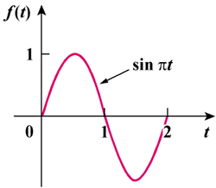

Figure 18.36
For Prob. 18.11.

Solution

f(t) = sin π t [u(t) - u(t - 2)]

F(ω) =

